**Phase 3: Project Implementation**

**Title: ENERGY USAGE OPTIMIZATION**

**Objective**

The objective of Phase 3 is to build and deploy analytical components of an Energy

Usage Optimization System, designed to monitor and analyze energy consumption

across multiple building types. The system delivers interactive charts, usage trends, and

efficiency insights using statistical tools and visualizations.

**1. Analytical Model Development**

**Overview**

This phase develops a model to interpret energy usage patterns across building

categories such as Residential, Commercial, and Industrial over a defined period.

**Implementation**

**Usage Pattern Model:** Analyzes time-series energy usage data to detect peak usage

periods, inefficiencies, and optimal performance windows.

**Data Source:** Simulated energy consumption data over 6 months; future integration

with smart meters and IoT feeds.

**Outcome**

The model identifies:

Peak consumption periods in each category.

Efficiency comparison across building types. Volatility or consistency in usage using

statistical distributions (e.g., histogram).

**2. Dashboard Interface Development**

**Overview**

A user-friendly dashboard to visualize interactive insights and energy usage trends for

facility managers and analysts.

**Implementation**

**User Interaction:** Interactive charts — bar, pie, line, and histogram — to explore energy

patterns.

**Platform Support:** Web-based, responsive design for desktop and mobile access.

**Outcome**

Users can:

Track month-wise energy trends.

Compare energy use by category.

Visualize distribution and peak periods.

**3. Data Visualization Implementation**

**Overview**

Visualize key energy patterns using Python libraries such as matplotlib and seaborn.

**Implementation**

**Line Chart:** Monthly energy usage trends.

**Bar Chart:** Last month's usage comparison.

**Pie Chart:** Proportion of energy usage by category.

**Histogram:** Usage consistency for a category.

**Outcome**

Stakeholders derive actionable insights, monitor energy-saving initiatives, and prioritize

infrastructure upgrades.

**4. Data Security (Optional)**

**Overview**

Structure to ensure secure storage of real-time and personal energy data is considered.

**Implementation**

Placeholder protocols for encrypted storage and future real-time data protection.

**Outcome**

Compliant with secure cloud or enterprise-grade deployment.

**5. Testing and Feedback Collection**

**Overview**

Testing ensures accuracy of analytics and dashboard usability.

**Implementation**

**Trial Evaluation:** Using dummy energy data for clarity.

**Feedback Loop:** Collected from energy consultants and IT teams.

**Outcome**

Refinement of visual layout and real-time integration roadmap for Phase 4.

**Outcomes of Phase 3**

**Energy Analytics Engine:** Identifies inefficiencies and consumption trends.

**Interactive Dashboard:** Real-time energy usage display.

**Visualization Suite:** Actionable insights for sustainability decisions.

**Next Steps for Phase 4**

1. Integration with smart grid or real-time IoT data.

2. Predictive modeling for future consumption (e.g., LSTM, ARIMA).

3. Advanced dashboard filters (e.g., Here’s by region, time of day, appliance type).

**Python Code:**

Import pandas as pd

Import matplotlib.pyplot as plt

Import numpy as np

# Load the data

# Replace ‘your_data.xlsx’ with your actual file

Df = pd.read_excel(“your_data.xlsx”)

# Ensure proper column names

Df.columns = [‘Time’, ‘Category’, ‘Usage_kWh’]

# Aggregate data

Total_usage_by_time = df.groupby(‘Time’)[‘Usage_kWh’].sum()

Total_usage_by_category = df.groupby(‘Category’)[‘Usage_kWh’].sum()

# Optimization: Find peak usage periods

Peak_time = total_usage_by_time.idxmax()

Peak_usage = total_usage_by_time.max()

Print(f”Peak usage time: {peak_time} with {peak_usage:.2f} kWh”)

# Plot Line Chart – Energy usage over time

Plt.figure(figsize=(10, 6))

Total_usage_by_time.plot(kind=’line’, marker=’o’)

Plt.title(“Energy Usage Over Time”)

Plt.xlabel(“Time”)

Plt.ylabel(“Energy (kWh)”)

Plt.grid(True)

Plt.tight_layout()

Plt.savefig(“line_chart.png”)

Plt.show()

# Plot Bar Chart – Usage by category

Plt.figure(figsize=(10, 6))

Total_usage_by_category.plot(kind=’bar’, color=’skyblue’)

Plt.title(“Energy Usage by Category”)

Plt.xlabel(“Category”)

Plt.ylabel(“Total Energy (kWh)”)

Plt.xticks(rotation=45)

Plt.tight_layout()

Plt.savefig(“bar_chart.png”)

Plt.show()

# Plot Pie Chart – Usage distribution by category

Plt.figure(figsize=(8, 8))

Total_usage_by_category.plot(kind=’pie’, autopct=’%1.1f%%’)

Plt.title(“Energy Usage Distribution by Category”)

Plt.ylabel(“”) # Hide y-axis label

Plt.tight_layout()

Plt.savefig(“pie_chart.png”)

Plt.show()

# Plot Histogram – Frequency of usage levels

Plt.figure(figsize=(10, 6))

Plt.hist(df[‘Usage_kWh’], bins=10, color=’lightgreen’, edgecolor=’black’)

Plt.title(“Distribution of Energy Usage”)

Plt.xlabel(“Energy (kWh)”)

Plt.ylabel(“Frequency”)

Plt.tight_layout()

Plt.savefig(“histogram.png”)

Plt.show()

**Line Chart:**

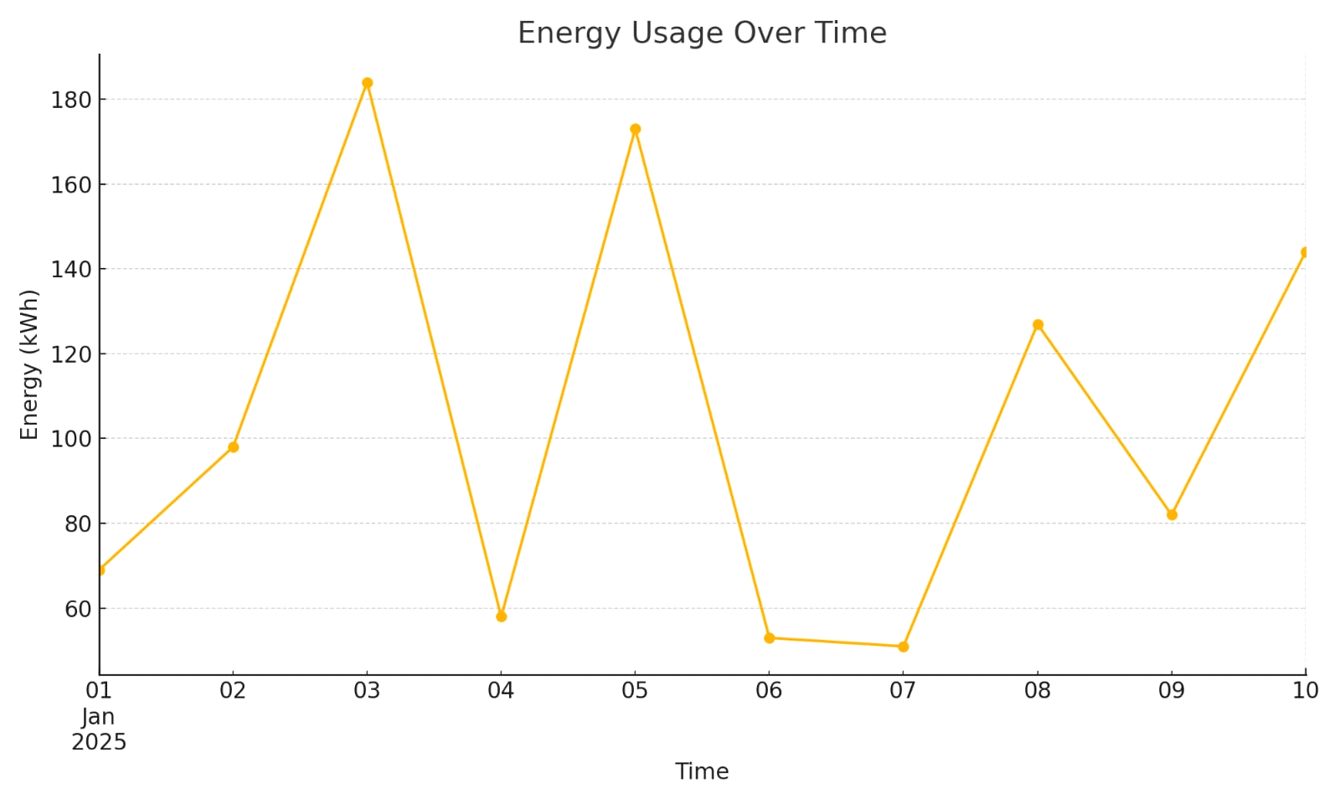

**Bar Chart :**

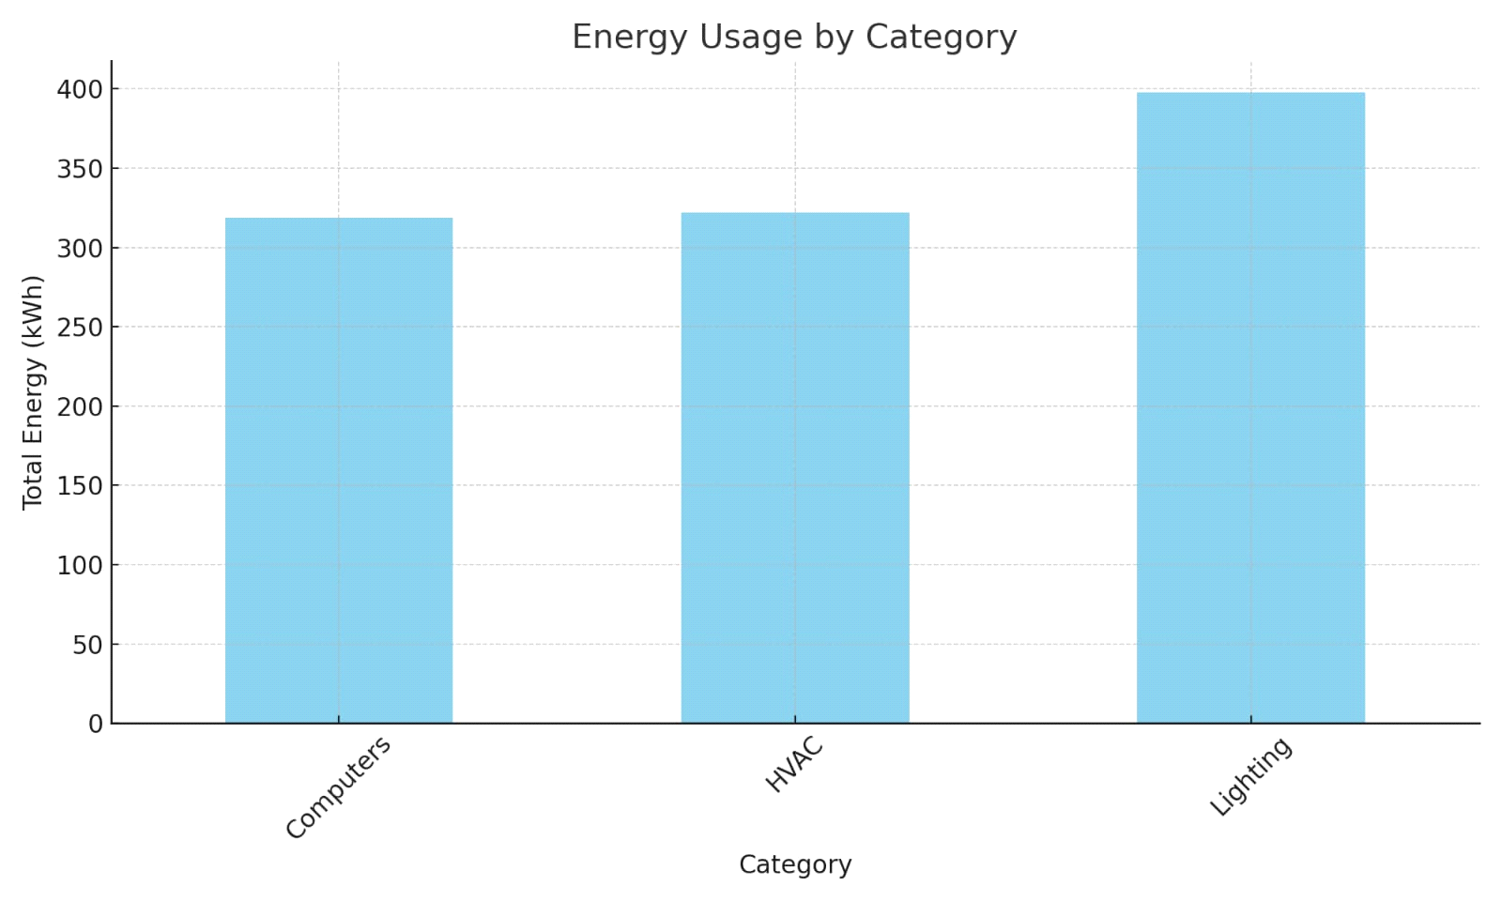

**Histogram :**

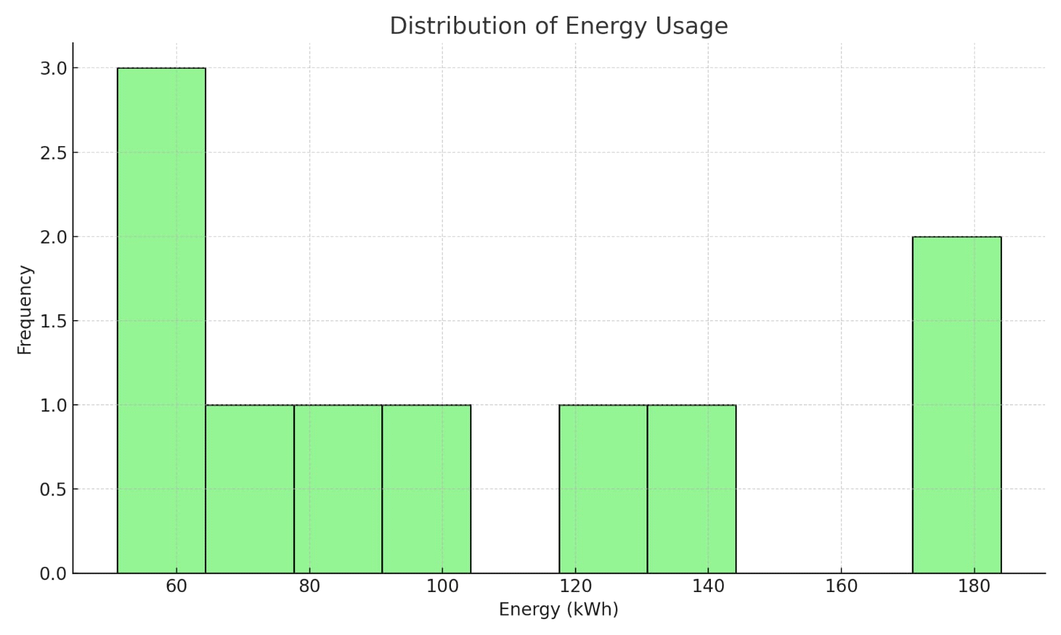

**Pie Chart :**

